STAT350 Lab5

Tian Qiu

Instructor: Womble

A. 1.

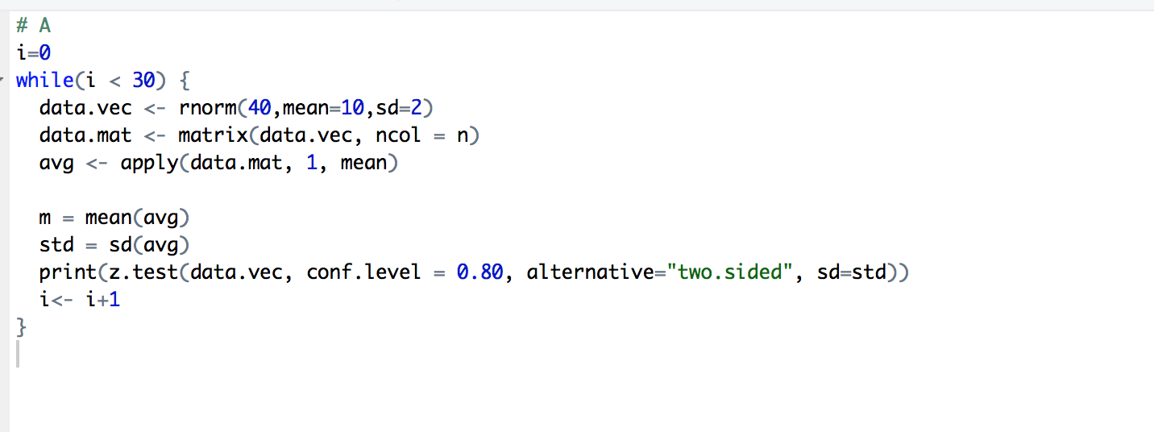

1. 2.

One Sample z-test

data: data.vec

z = 138.48, n = 40.000000, Std. Dev. = 0.455070, Std. Dev. of the sample mean = 0.071953, p-value < 2.2e-16

alternative hypothesis: true mean is not equal to 0

80 percent confidence interval:

9.871684 10.056108

sample estimates:

mean of data.vec

9.963896

One Sample z-test

data: data.vec

z = 316.67, n = 40.00000, Std. Dev. = 0.20833, Std. Dev. of the sample mean = 0.03294, p-value < 2.2e-16

alternative hypothesis: true mean is not equal to 0

80 percent confidence interval:

10.38871 10.47314

sample estimates:

mean of data.vec

10.43093

One Sample z-test

data: data.vec

z = 194.78, n = 40.000000, Std. Dev. = 0.330230, Std. Dev. of the sample mean = 0.052214, p-value < 2.2e-16

alternative hypothesis: true mean is not equal to 0

80 percent confidence interval:

10.10344 10.23727

sample estimates:

mean of data.vec

10.17035

One Sample z-test

data: data.vec

z = 52.202, n = 40.00000, Std. Dev. = 1.22650, Std. Dev. of the sample mean = 0.19393, p-value < 2.2e-16

alternative hypothesis: true mean is not equal to 0

80 percent confidence interval:

9.87479 10.37185

sample estimates:

mean of data.vec

10.12332

One Sample z-test

data: data.vec

z = 93.652, n = 40.00000, Std. Dev. = 0.68529, Std. Dev. of the sample mean = 0.10835, p-value < 2.2e-16

alternative hypothesis: true mean is not equal to 0

80 percent confidence interval:

10.00879 10.28651

sample estimates:

mean of data.vec

10.14765

One Sample z-test

data: data.vec

z = 207.54, n = 40.000000, Std. Dev. = 0.311880, Std. Dev. of the sample mean = 0.049313, p-value < 2.2e-16

alternative hypothesis: true mean is not equal to 0

80 percent confidence interval:

10.17148 10.29787

sample estimates:

mean of data.vec

10.23468

One Sample z-test

data: data.vec

z = 127.34, n = 40.000000, Std. Dev. = 0.487950, Std. Dev. of the sample mean = 0.077151, p-value < 2.2e-16

alternative hypothesis: true mean is not equal to 0

80 percent confidence interval:

9.725311 9.923057

sample estimates:

mean of data.vec

9.824184

One Sample z-test

data: data.vec

z = 79.571, n = 40.00000, Std. Dev. = 0.83597, Std. Dev. of the sample mean = 0.13218, p-value < 2.2e-16

alternative hypothesis: true mean is not equal to 0

80 percent confidence interval:

10.34827 10.68706

sample estimates:

mean of data.vec

10.51766

One Sample z-test

data: data.vec

z = 206.88, n = 40.000000, Std. Dev. = 0.295750, Std. Dev. of the sample mean = 0.046762, p-value < 2.2e-16

alternative hypothesis: true mean is not equal to 0

80 percent confidence interval:

9.614249 9.734104

sample estimates:

mean of data.vec

9.674177

One Sample z-test

data: data.vec

z = 183.83, n = 40.000000, Std. Dev. = 0.335950, Std. Dev. of the sample mean = 0.053118, p-value < 2.2e-16

alternative hypothesis: true mean is not equal to 0

80 percent confidence interval:

9.696544 9.832691

sample estimates:

mean of data.vec

9.764617

One Sample z-test

data: data.vec

z = 42.817, n = 40.00000, Std. Dev. = 1.43210, Std. Dev. of the sample mean = 0.22644, p-value < 2.2e-16

alternative hypothesis: true mean is not equal to 0

80 percent confidence interval:

9.405435 9.985828

sample estimates:

mean of data.vec

9.695632

One Sample z-test

data: data.vec

z = 266.83, n = 40.000000, Std. Dev. = 0.227220, Std. Dev. of the sample mean = 0.035927, p-value < 2.2e-16

alternative hypothesis: true mean is not equal to 0

80 percent confidence interval:

9.540203 9.632287

sample estimates:

mean of data.vec

9.586245

One Sample z-test

data: data.vec

z = 141.32, n = 40.000000, Std. Dev. = 0.468100, Std. Dev. of the sample mean = 0.074014, p-value < 2.2e-16

alternative hypothesis: true mean is not equal to 0

80 percent confidence interval:

10.36509 10.55480

sample estimates:

mean of data.vec

10.45995

One Sample z-test

data: data.vec

z = 142.4, n = 40.000000, Std. Dev. = 0.429010, Std. Dev. of the sample mean = 0.067832, p-value < 2.2e-16

alternative hypothesis: true mean is not equal to 0

80 percent confidence interval:

9.572130 9.745992

sample estimates:

mean of data.vec

9.659061

One Sample z-test

data: data.vec

z = 103.34, n = 40.000000, Std. Dev. = 0.610170, Std. Dev. of the sample mean = 0.096477, p-value < 2.2e-16

alternative hypothesis: true mean is not equal to 0

80 percent confidence interval:

9.846288 10.093568

sample estimates:

mean of data.vec

9.969928

One Sample z-test

data: data.vec

z = 71.359, n = 40.00000, Std. Dev. = 0.92940, Std. Dev. of the sample mean = 0.14695, p-value < 2.2e-16

alternative hypothesis: true mean is not equal to 0

80 percent confidence interval:

10.29783 10.67448

sample estimates:

mean of data.vec

10.48615

One Sample z-test

data: data.vec

z = 116.74, n = 40.000000, Std. Dev. = 0.530360, Std. Dev. of the sample mean = 0.083858, p-value < 2.2e-16

alternative hypothesis: true mean is not equal to 0

80 percent confidence interval:

9.681850 9.896786

sample estimates:

mean of data.vec

9.789318

One Sample z-test

data: data.vec

z = 119.45, n = 40.000000, Std. Dev. = 0.522000, Std. Dev. of the sample mean = 0.082535, p-value < 2.2e-16

alternative hypothesis: true mean is not equal to 0

80 percent confidence interval:

9.753376 9.964923

sample estimates:

mean of data.vec

9.859149

One Sample z-test

data: data.vec

z = 117.42, n = 40.000000, Std. Dev. = 0.530520, Std. Dev. of the sample mean = 0.083882, p-value < 2.2e-16

alternative hypothesis: true mean is not equal to 0

80 percent confidence interval:

9.742195 9.957194

sample estimates:

mean of data.vec

9.849694

One Sample z-test

data: data.vec

z = 158, n = 40.000000, Std. Dev. = 0.394660, Std. Dev. of the sample mean = 0.062401, p-value < 2.2e-16

alternative hypothesis: true mean is not equal to 0

80 percent confidence interval:

9.779286 9.939227

sample estimates:

mean of data.vec

9.859257

One Sample z-test

data: data.vec

z = 66.264, n = 40.00000, Std. Dev. = 0.96336, Std. Dev. of the sample mean = 0.15232, p-value < 2.2e-16

alternative hypothesis: true mean is not equal to 0

80 percent confidence interval:

9.898161 10.288574

sample estimates:

mean of data.vec

10.09337

One Sample z-test

data: data.vec

z = 90.498, n = 40.00000, Std. Dev. = 0.67441, Std. Dev. of the sample mean = 0.10663, p-value < 2.2e-16

alternative hypothesis: true mean is not equal to 0

80 percent confidence interval:

9.513522 9.786836

sample estimates:

mean of data.vec

9.650179

One Sample z-test

data: data.vec

z = 87.328, n = 40.00000, Std. Dev. = 0.72398, Std. Dev. of the sample mean = 0.11447, p-value < 2.2e-16

alternative hypothesis: true mean is not equal to 0

80 percent confidence interval:

9.849939 10.143343

sample estimates:

mean of data.vec

9.996641

One Sample z-test

data: data.vec

z = 101.08, n = 40.000000, Std. Dev. = 0.608930, Std. Dev. of the sample mean = 0.096281, p-value < 2.2e-16

alternative hypothesis: true mean is not equal to 0

80 percent confidence interval:

9.608819 9.855597

sample estimates:

mean of data.vec

9.732208

One Sample z-test

data: data.vec

z = 132.42, n = 40.000000, Std. Dev. = 0.490630, Std. Dev. of the sample mean = 0.077576, p-value < 2.2e-16

alternative hypothesis: true mean is not equal to 0

80 percent confidence interval:

10.17299 10.37183

sample estimates:

mean of data.vec

10.27241

One Sample z-test

data: data.vec

z = 61.505, n = 40.00000, Std. Dev. = 0.97596, Std. Dev. of the sample mean = 0.15431, p-value < 2.2e-16

alternative hypothesis: true mean is not equal to 0

80 percent confidence interval:

9.293369 9.688891

sample estimates:

mean of data.vec

9.49113

One Sample z-test

data: data.vec

z = 136.37, n = 40.00000, Std. Dev. = 0.49009, Std. Dev. of the sample mean = 0.07749, p-value < 2.2e-16

alternative hypothesis: true mean is not equal to 0

80 percent confidence interval:

10.46826 10.66687

sample estimates:

mean of data.vec

10.56757

One Sample z-test

data: data.vec

z = 98.675, n = 40.000000, Std. Dev. = 0.602510, Std. Dev. of the sample mean = 0.095265, p-value < 2.2e-16

alternative hypothesis: true mean is not equal to 0

80 percent confidence interval:

9.278205 9.522378

sample estimates:

mean of data.vec

9.400292

One Sample z-test

data: data.vec

z = 209.85, n = 40.000000, Std. Dev. = 0.288980, Std. Dev. of the sample mean = 0.045691, p-value < 2.2e-16

alternative hypothesis: true mean is not equal to 0

80 percent confidence interval:

9.529825 9.646936

sample estimates:

mean of data.vec

9.58838

One Sample z-test

data: data.vec

z = 77.165, n = 40.00000, Std. Dev. = 0.78760, Std. Dev. of the sample mean = 0.12453, p-value < 2.2e-16

alternative hypothesis: true mean is not equal to 0

80 percent confidence interval:

9.449834 9.769018

sample estimates:

mean of data.vec

9.609426

1. 3.

Four of these intervals contain the population mean u=10, which is highlighted with yellow. It is what I have expected, because 40 random normal distribution number is not enough to limit the interval precisely.

B.1.

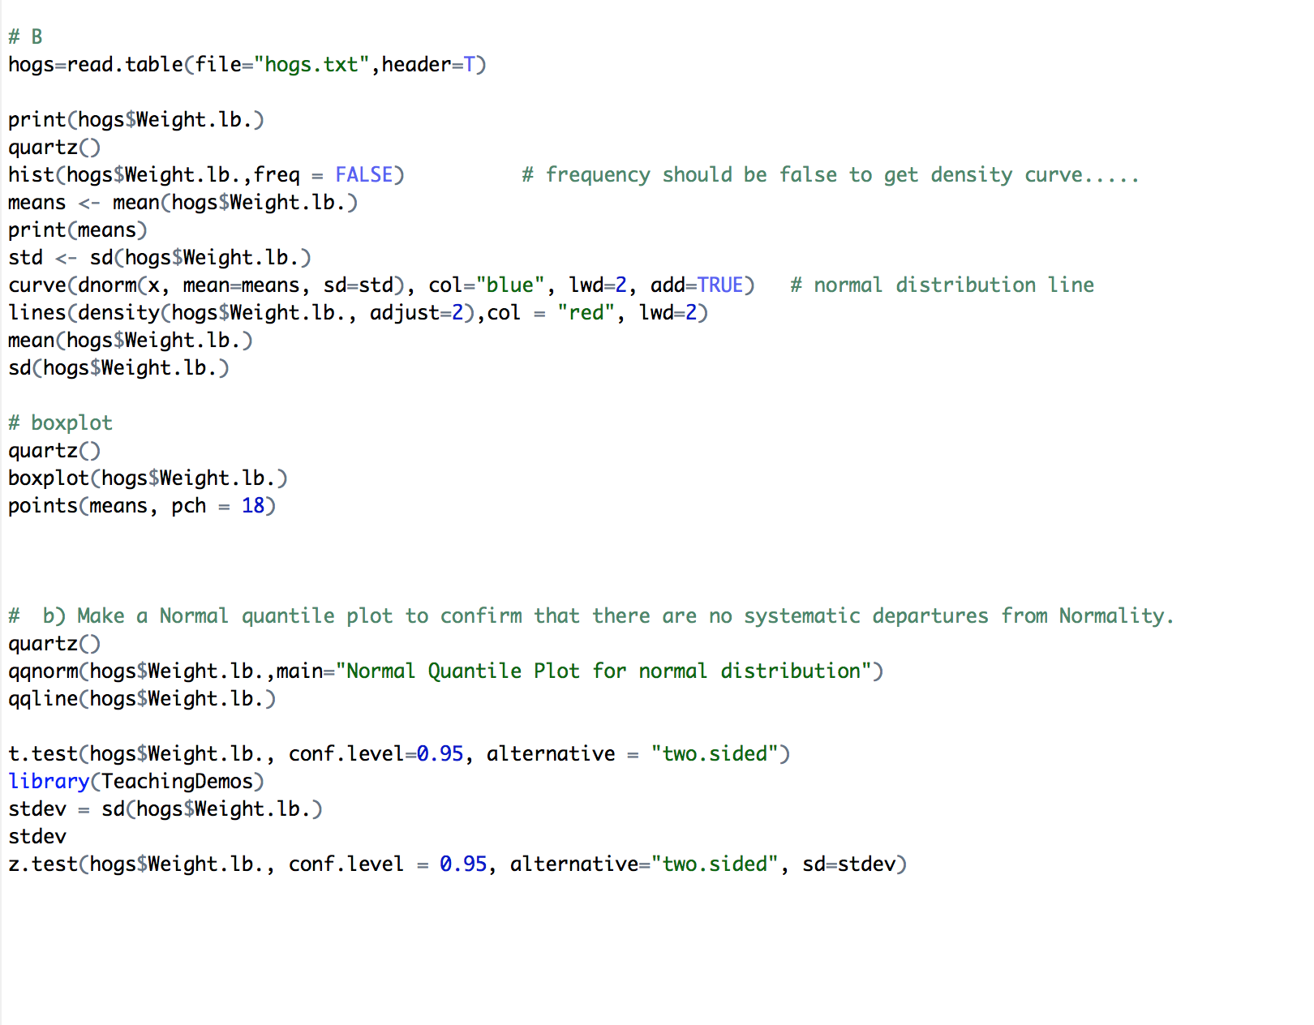

B.2

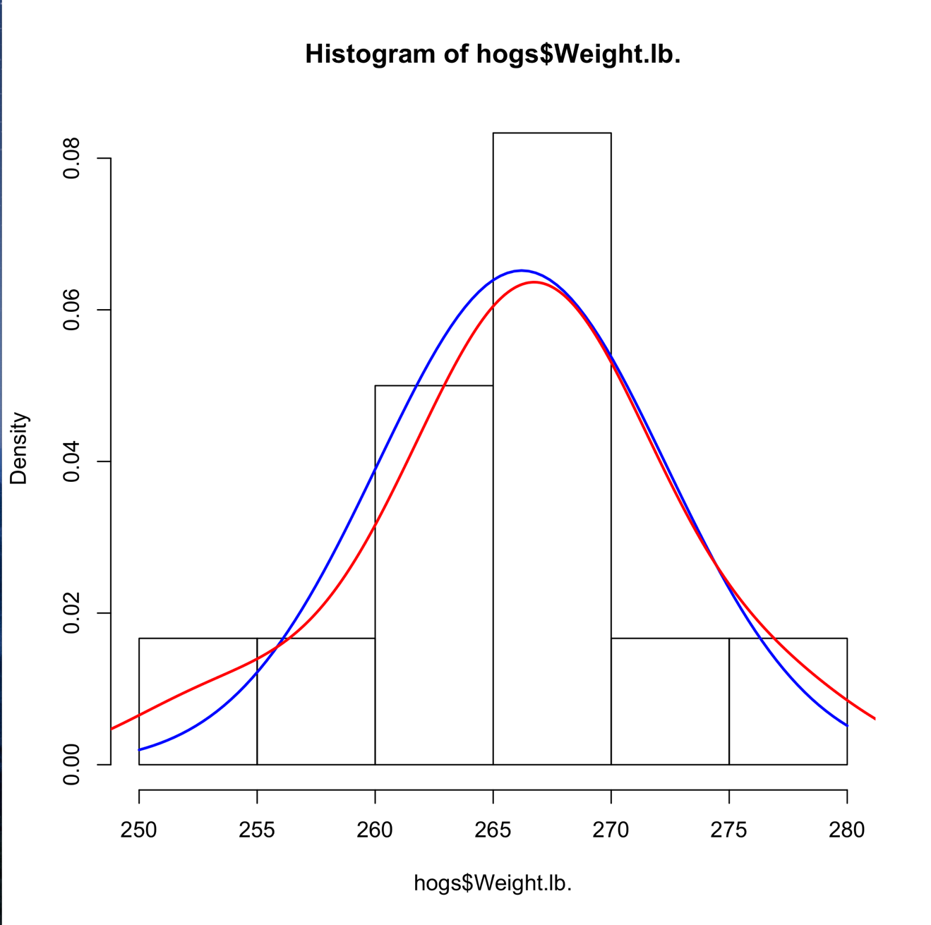

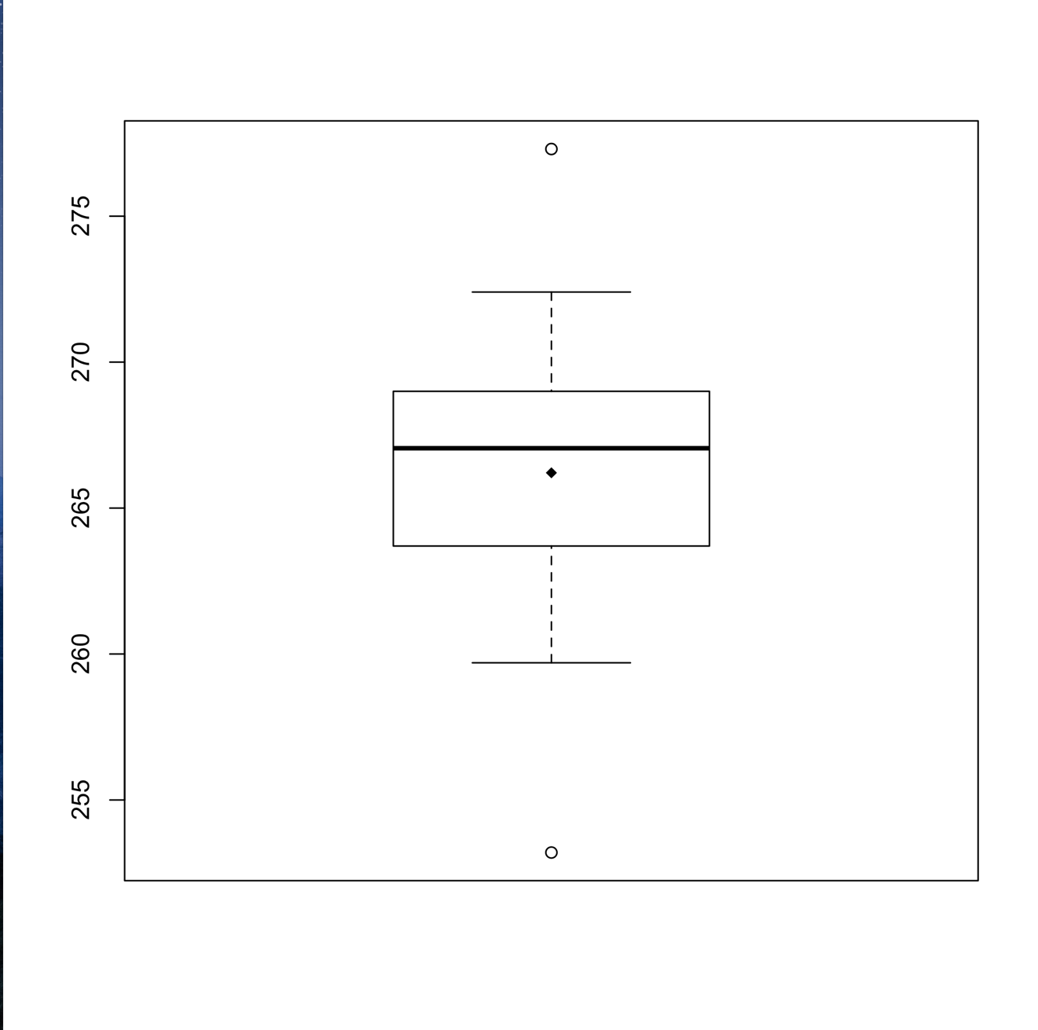

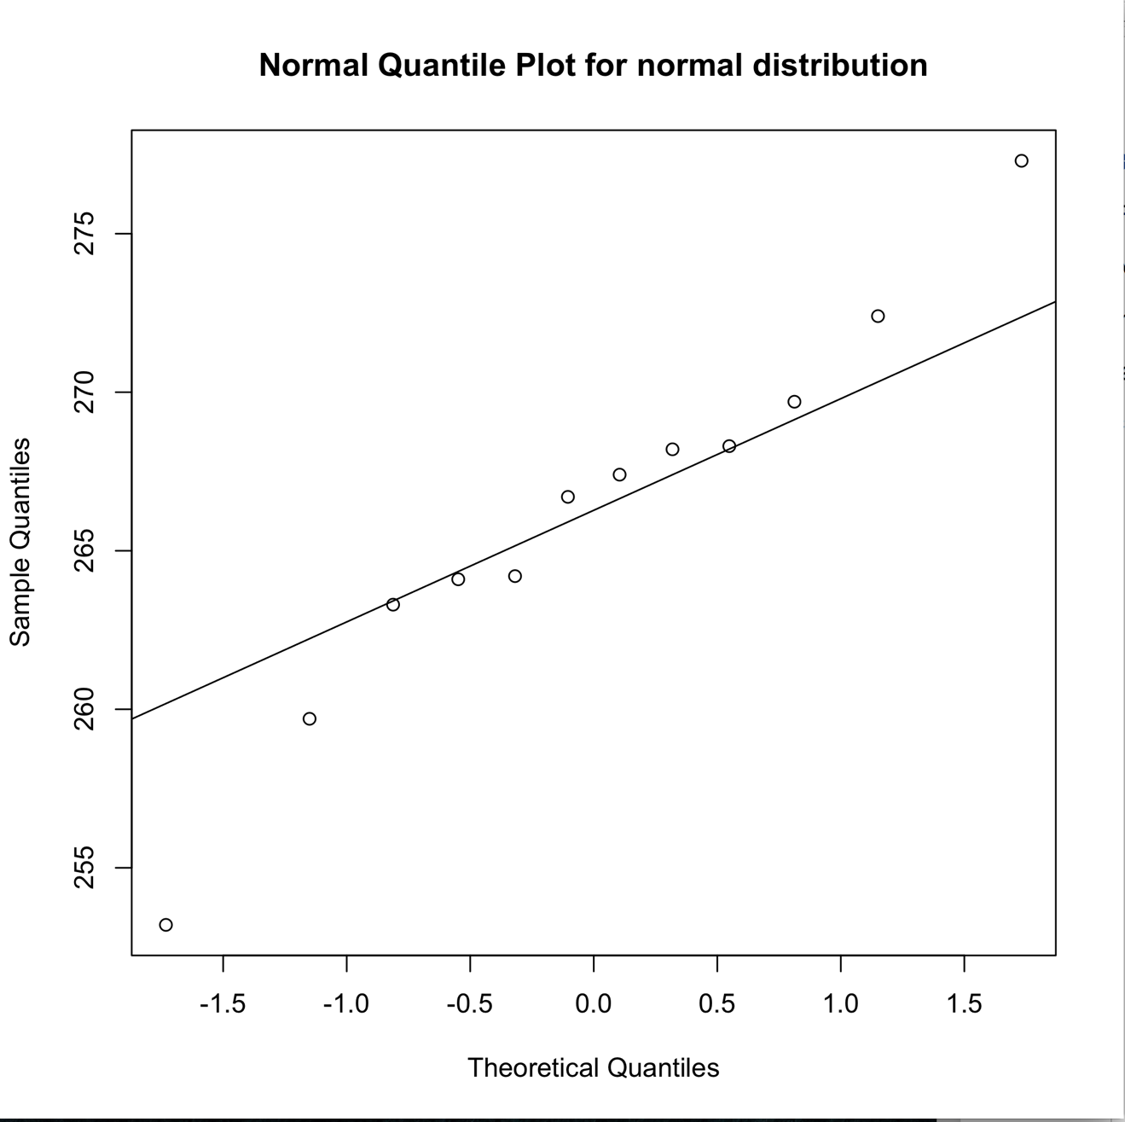

B.3.

The distribution is slightly skewed to the left but totally symmetric. Also, it has few outliers hence the graph looks pretty normally distributed.

B.4.

It is appropriate to analyze these data using the t procedures because the question only offered the population mean. We do not have any information about population variance and we do know the sample mean and the sample variance. Hence, using t test is appropriate.

B.5.

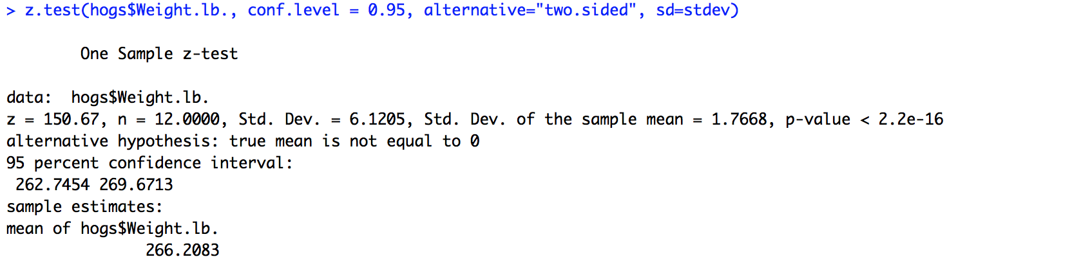

B.6.

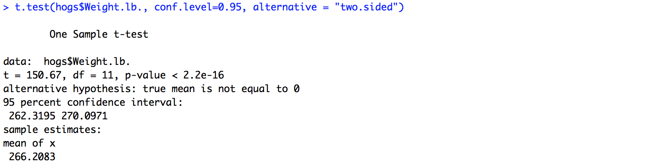

B.7.

These two intervals are different because we use different test procedures. In z-test we do not consider degree of freedom while in t-test we do consider DF.

B.8.

We do have evidence to reject the claim that μ = 275.4 because 275.4 is not included in t-test confidence interval we calculated.